ML Lab 2

Name: Saptanshu Wanjari

Class: C1-A2

Roll No: 18
Lab No.: 2
Lab Aim and Objective: To implement Simple Linear Regression on the USA Housing dataset and predict the price of a house from the average area income of the area.
Dataset or Resources Used: USA_Housing.csv (5000 rows, 7 columns). Tools: Python 3.12, Jupyter Notebook, pandas, numpy, matplotlib, seaborn, scikit-learn.
Date of Performance: 15 July 2026

1. Theory

1.1 What is Simple Linear Regression?
Simple Linear Regression is a supervised machine learning algorithm used for regression problems. It finds a straight line that best fits the given data, where the output depends on a single input feature. The line is fitted by minimizing the error between the actual and predicted values, using the least squares method. The equation of the line is y = mx + c, where m is the slope and c is the intercept.

1.2 About the Dataset
The USA Housing dataset contains 5000 records of houses sold in different areas of the USA. Each row has the average area income, average house age, number of rooms, number of bedrooms, area population and the final house price. The Address column is just text and not useful for prediction, so we drop it. We use Avg. Area Income as the input feature and Price as the target.

1.2 Techniques Applied
• Loaded and inspected the data with head, tail, shape and info.
• Checked for missing values and duplicates (both are zero).
• Dropped the Address column as it is text and not useful.
• Did EDA with a correlation heatmap, histplots, scatter plot and box plots.
• Found outliers in income using the IQR method (32 rows).
• Split the data into train (4000) and test (1000).
• Trained a LinearRegression model and evaluated it with MAE, MSE, RMSE and R2 score.

2. Code with GitHub URL
The complete code for this lab is written in a Jupyter Notebook and uploaded to GitHub:
https://github.com/SaptanshuWanjari/3rd-Year-/blob/main/ML/lab/15-7-Lab-2/C1_A2_18-Saptanshu_Wanjari-Lab-2.ipynb
https://github.com/SaptanshuWanjari/3rd-Year-/blob/main/ML/lab/15-7-Lab-2/C1_A2_18-Saptanshu_Wanjari-Lab-2.py
The complete written code is given below:
#!/usr/bin/env python
# coding: utf-8
# In[1]:
import numpy as np
import pandas as pd
import matplotlib.pyplot as plt
import seaborn as sns
from sklearn.model_selection import train_test_split
from sklearn.linear_model import LinearRegression
from sklearn import metrics
# In[2]:
df=pd.read_csv("USA_Housing.csv")
df.head()
# In[3]:
df.tail()
# In[4]:
df.shape
# In[5]:
df.columns
# In[6]:
df.info()
# In[7]:
df.describe()
# In[8]:
df.isnull().sum()
# In[9]:
df.duplicated().sum()
# In[10]:
if 'Address' in df.columns:
df.drop('Address', axis=1, inplace=True)
# In[11]:
plt.figure(figsize=(10,6))
corr_matrix=df.corr()
sns.heatmap(corr_matrix, annot=True, cmap='coolwarm',fmt=".2f",linewidths=0.5)
plt.title("Feature Correlation Matrix")
plt.show()
# In[12]:
plt.figure(figsize=(8,5))
sns.histplot(df["Price"], kde=True)
plt.title("Distribution of House Price")
plt.show()
# In[13]:
plt.figure(figsize=(8,5))
sns.histplot(df["Avg. Area Income"], kde=True)
plt.title("Distribution of Avg. Area Income")
plt.show()
# In[14]:
sns.scatterplot(x="Avg. Area Income",y="Price",data=df)
plt.show()
# In[15]:
sns.boxplot(x=df["Avg. Area Income"])
plt.show()
# In[16]:
sns.boxplot(x=df["Avg. Area Income"],y=df["Price"])
plt.show()
# In[17]:
# IQR method to find outliers in Avg. Area Income
q1=df["Avg. Area Income"].quantile(0.25)
q3=df["Avg. Area Income"].quantile(0.75)
iqr=q3-q1
lower=q1-1.5*iqr
upper=q3+1.5*iqr
outliers=df[(df["Avg. Area Income"]<lower)|(df["Avg. Area Income"]>upper)]
print("Q1:",q1)
print("Q3:",q3)
print("IQR:",iqr)
print("Outlier rows in Avg. Area Income:",len(outliers))
# In[18]:
pd.set_option('display.float_format','{:.2f}'.format)
# In[19]:
df.head()
# ## SLR
# In[20]:
X=df[['Avg. Area Income']]
y=df['Price']
# In[21]:
X_train,X_test,y_train,y_test = train_test_split(X,y,test_size=0.2,random_state=42)
print("Train shape:",X_train.shape)
print("Test shape:",X_test.shape)
# In[22]:
from sklearn.linear_model import LinearRegression
slr_model=LinearRegression()
slr_model.fit(X_train,y_train)
# In[23]:
y_pred=slr_model.predict(X_test)
# In[24]:
from sklearn.metrics import mean_absolute_error
from sklearn.metrics import mean_squared_error
from sklearn.metrics import r2_score
print("Simple Linear Regression Results")
print("------------------------------------")
print("MAE: ",mean_absolute_error(y_test,y_pred))
print("MSE: ",mean_squared_error(y_test,y_pred))
print("RMSE: ",np.sqrt(mean_squared_error(y_test,y_pred)))
print("R2 Score:",r2_score(y_test,y_pred))
# In[25]:
print("Intercept: ",slr_model.intercept_)
print("Slope: ",slr_model.coef_[0])
# In[26]:
plt.figure(figsize=(8,6))
plt.scatter(X_test,y_test,color='blue',label="Actual Data")
plt.plot(X_test,y_pred,color='red',linewidth=2,label="Regression Line")
plt.xlabel("Avg Area Income")
plt.ylabel("House Price")
plt.title("Simple Linear Regression")
plt.legend()
plt.show()
# In[27]:
# predicting house price for a new income value
new_data = pd.DataFrame({"Avg. Area Income":[80000]})
prediction = slr_model.predict(new_data)
print("Predicted House Price for income 80000: ${:,.2f}".format(prediction[0]))

3. Procedures and Materials Used

3.1 Materials Used
• Hardware: A laptop with any OS (Windows/Linux).
• Software: Python 3.12, Jupyter Notebook, pandas, numpy, matplotlib, seaborn, scikit-learn.
• Dataset: USA_Housing.csv downloaded from Kaggle.

3.2 Procedure
1. Load the USA_Housing.csv file using pandas read_csv.
2. Inspect the data using head, tail, shape, columns, info and describe.
3. Check for missing values and duplicates with isnull and duplicated.
4. Drop the Address column because it is text and not useful for prediction.
5. Plot EDA graphs like the correlation heatmap, histplots, scatter and box plots.
6. Find outliers in Avg. Area Income using the IQR method.
7. Separate X (Avg. Area Income) and y (Price), then split into train and test with 20% test size.
8. Train a LinearRegression model on the training data.
9. Predict on the test data and evaluate using MAE, MSE, RMSE and R2 score.
10. Plot the regression line and test the model on a new income value.

4. Output Screenshots with Descriptions

Output 1 – First 5 rows of the dataset
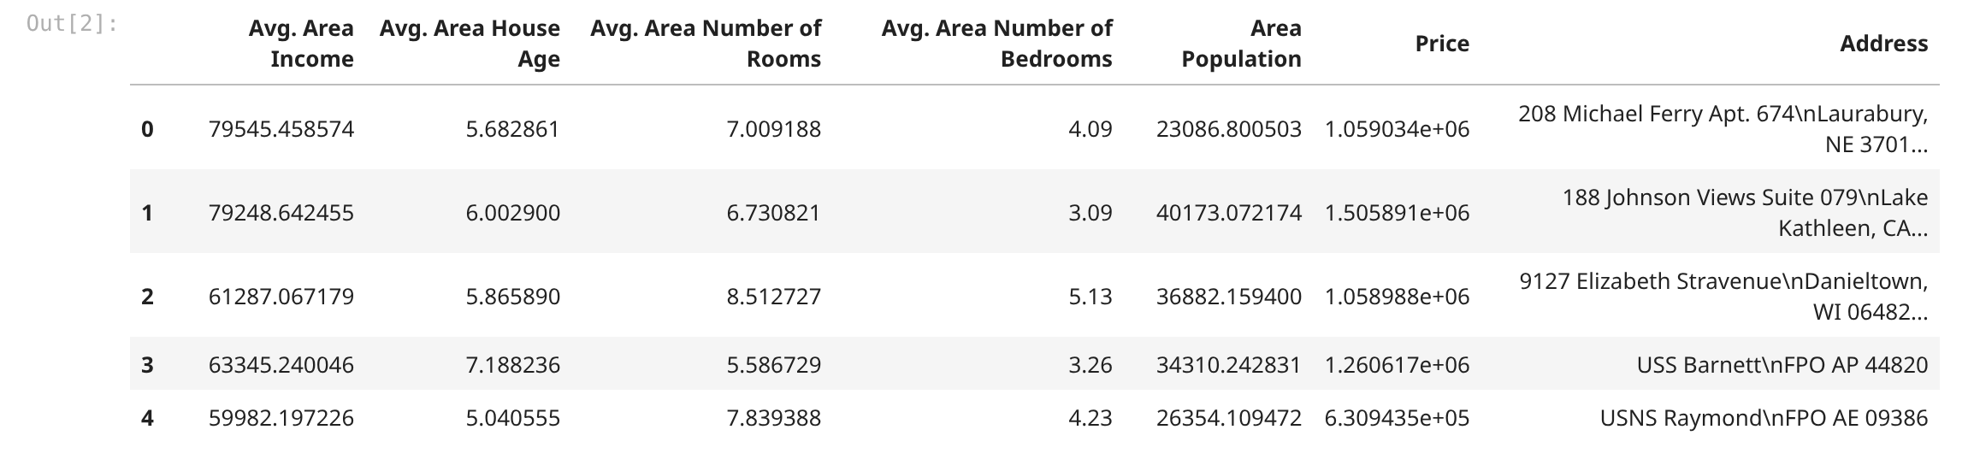
First 5 rows of the data. You can see there are 7 columns and 5000 rows total. Most columns are numbers and the Address column is text, so we drop it later.

Output 2 – Dataset info
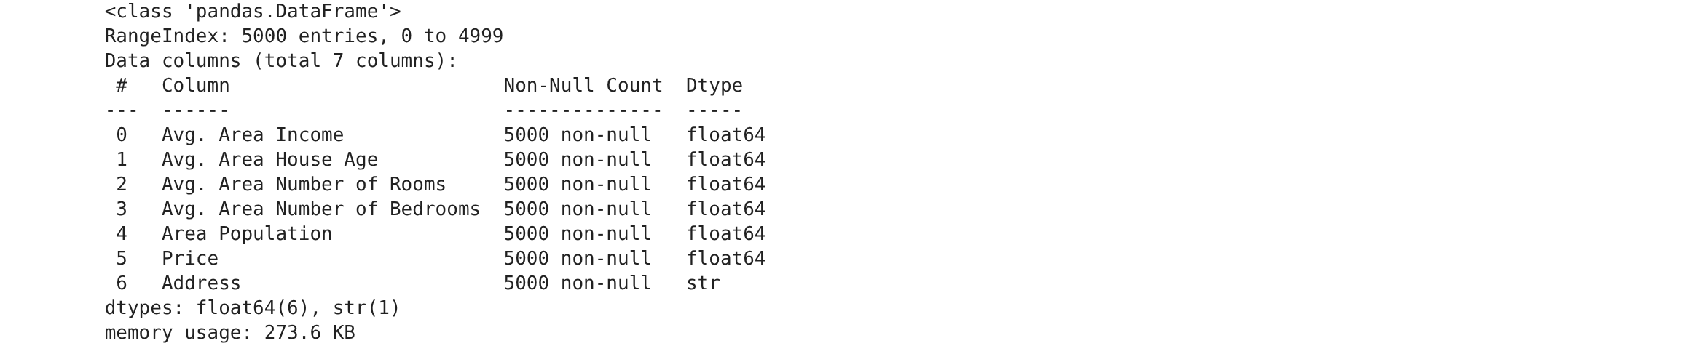
df.info() shows all the columns and their data types. All 7 columns have 5000 non-null values, so there are no missing values. Only Address is a string, the rest are float.

Output 3 – Statistical summary
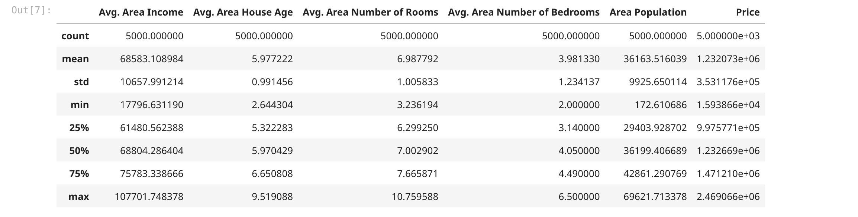
describe() gives the mean, min and max of each column. Average income is around 68583 and average house price is around 1.2 million. It shows how spread out the data is.

Output 4 – Missing values check
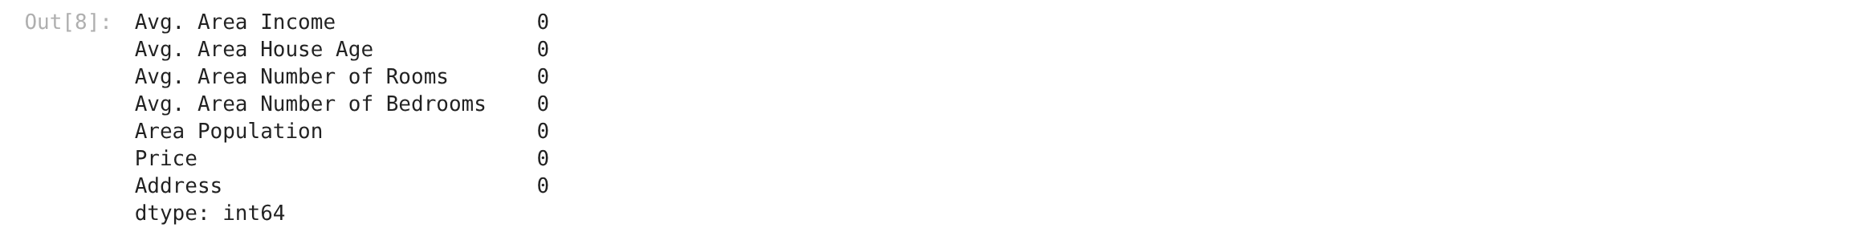
Checking for missing values. Every column shows 0, so the dataset is clean and we don't need to fill or drop anything.

Output 5 – Correlation heatmap
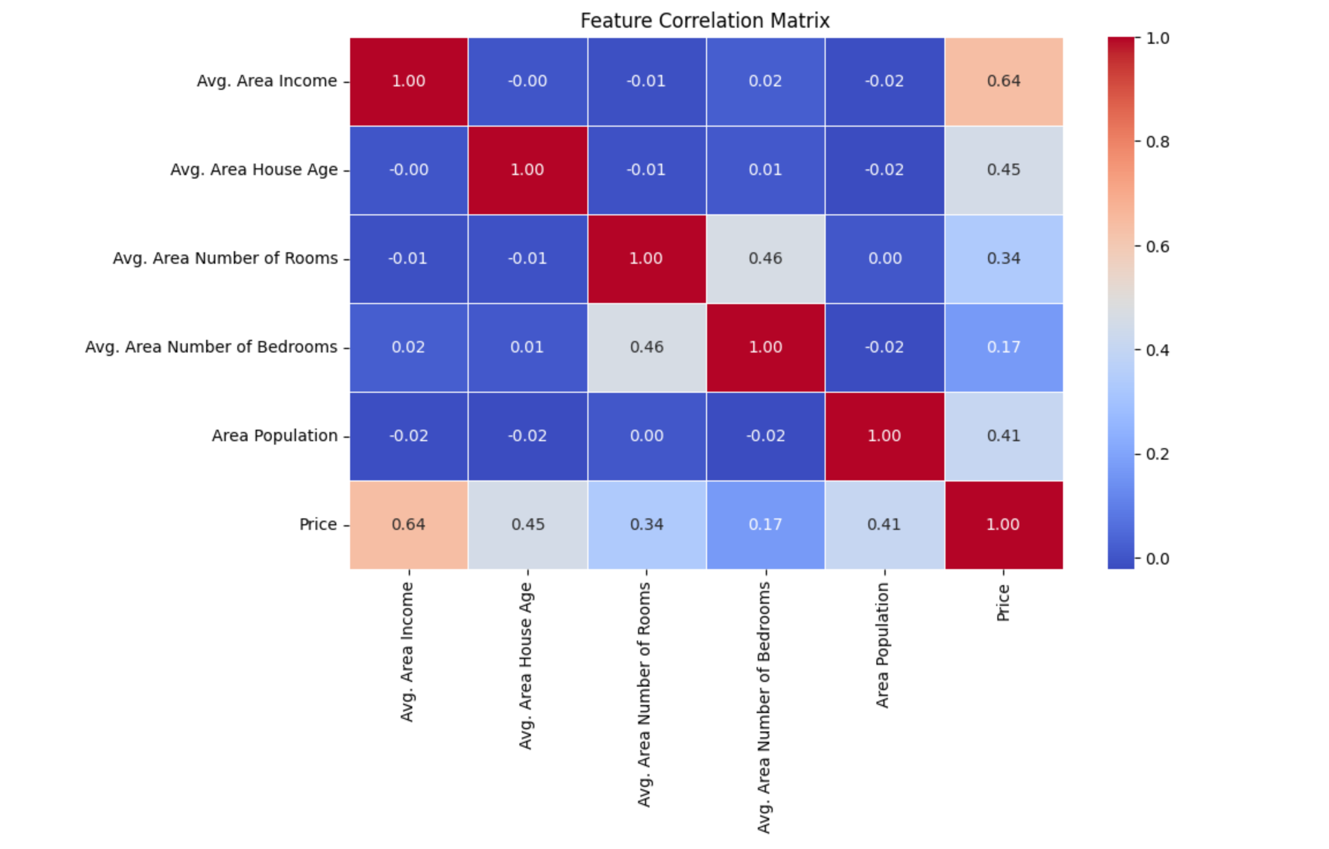
Correlation matrix as a heatmap. Income, house age, rooms and population all have a positive correlation with price. Income has the highest value.

Output 6 – Distribution of house price
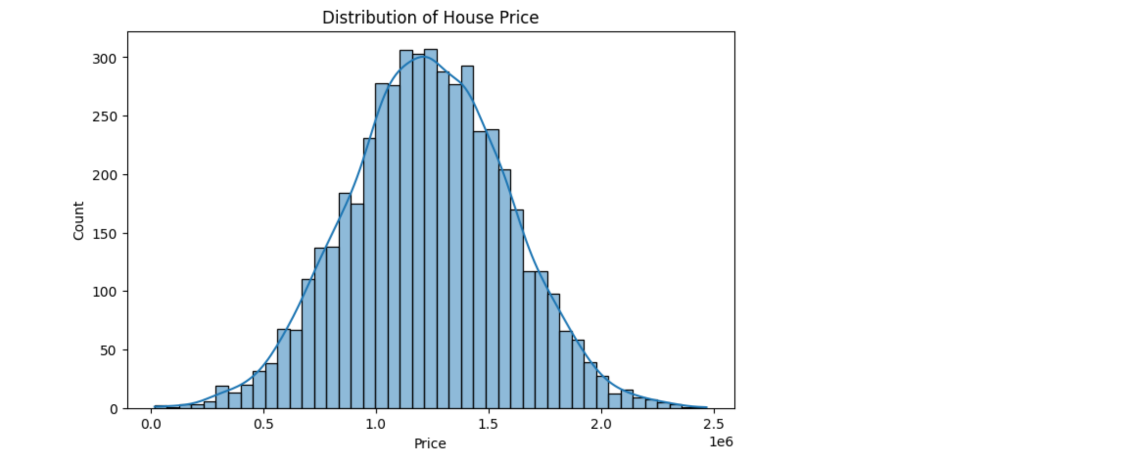
Histogram of house price with a KDE curve. The distribution is roughly bell shaped, most houses are around 1.1 to 1.3 million.

Output 7 – Income vs price scatter plot
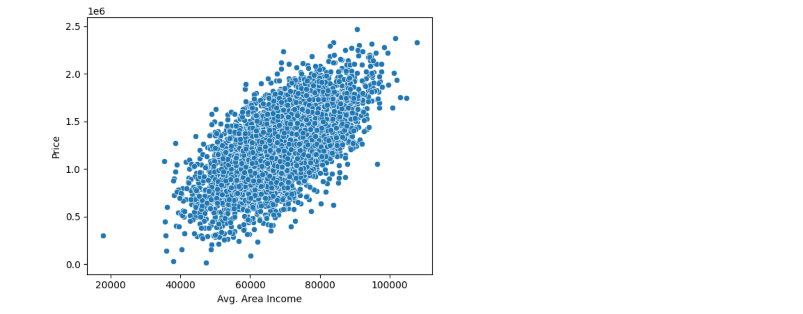
Scatter plot of income against price. The points go up from left to right, so higher income means higher price. That is why we use income as the feature.

Output 8 – Box plot of income
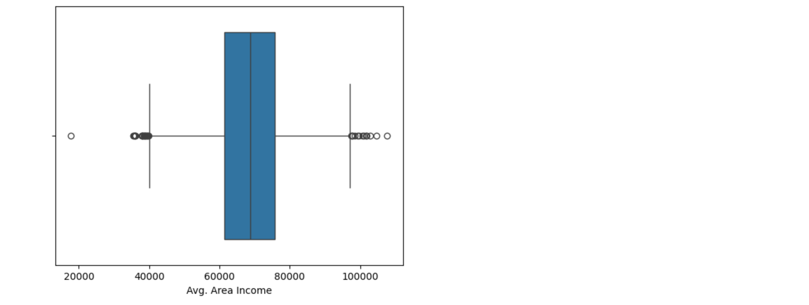
Box plot of Avg. Area Income. There are a few dots outside the whiskers, those are the outliers. Most values are between 60000 and 78000.

Output 9 – IQR outlier detection
IQR method for outliers. Q1 is 61480 and Q3 is 75783 so the IQR is 14302. There are 32 outlier rows for income, which is very few so we leave them.

Output 10 – Train test split sizes
Train test split with test size 0.2. Train shape is (4000, 1) and test shape is (1000, 1). random_state 42 keeps the split same every time.

Output 11 – Model evaluation metrics
The evaluation results. MAE is around 216826, RMSE is 272387 and R2 score is 0.39. So the model explains about 39% of the variation in price.

Output 12 – Regression line on test data
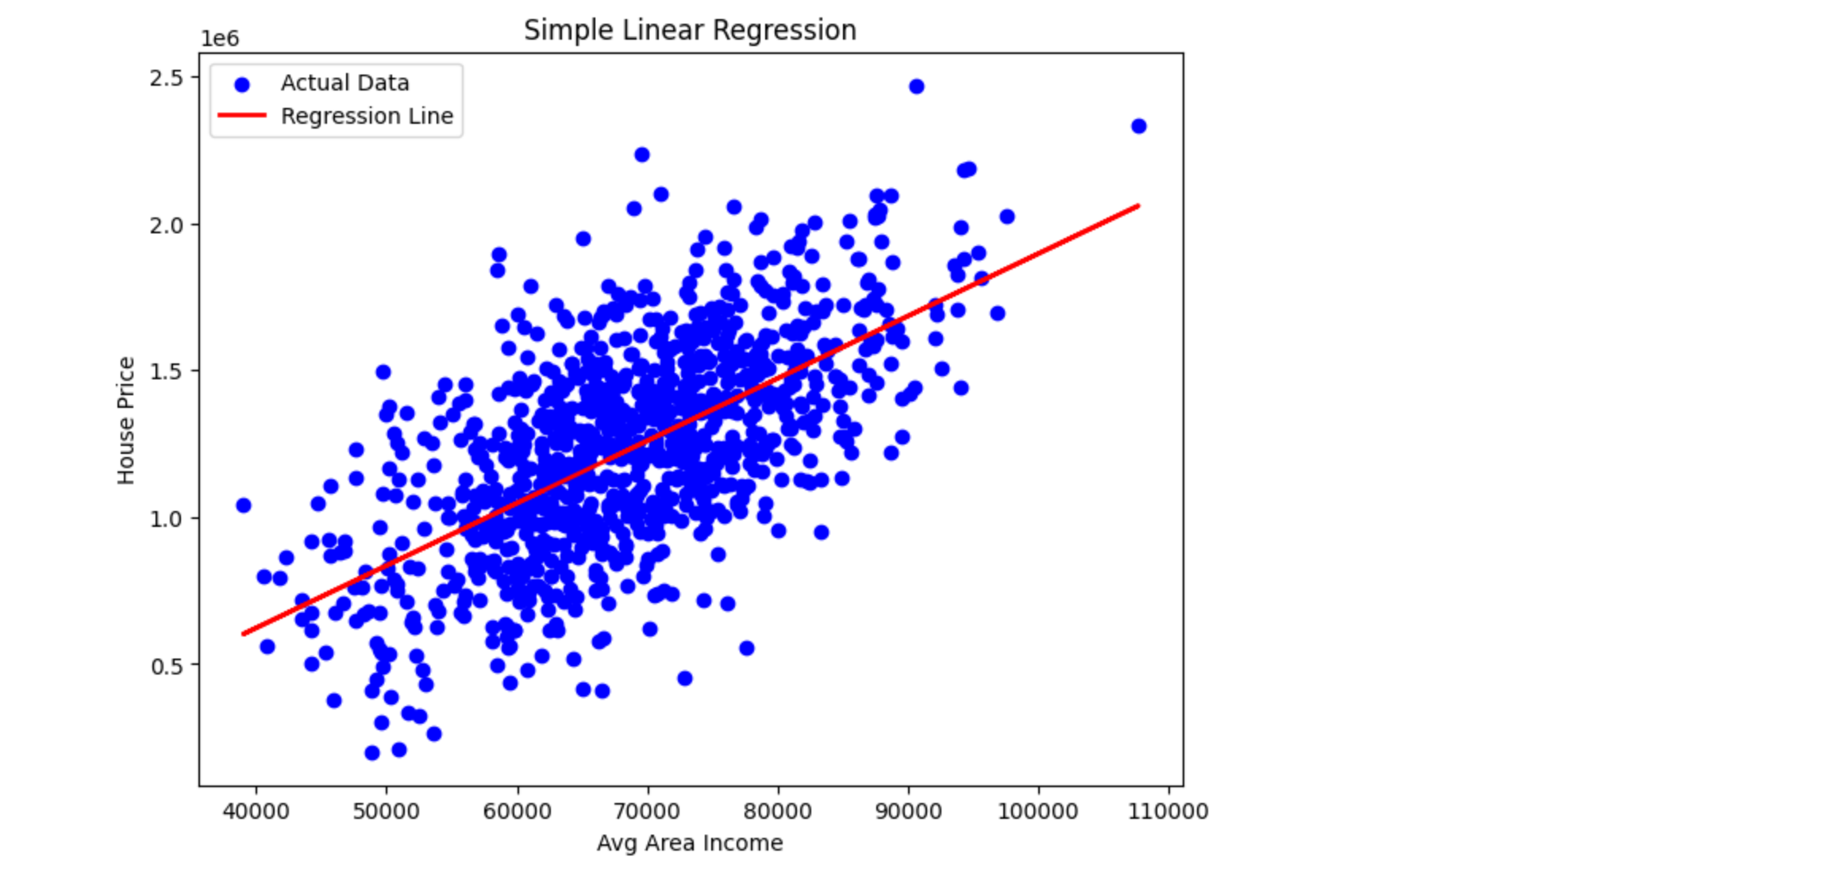
The regression line plotted over the test points. The red line rises with the blue actual points, so the linear relation is visible. For income 80000 the predicted price is about 1.47 million.

5. Viva Questions and Solutions
Q1. What is Simple Linear Regression?
Solution: Simple Linear Regression is a supervised algorithm that predicts a continuous output from one input feature. It fits a straight line y = mx + c by minimizing the sum of squared errors between actual and predicted values.
Q2. What is the difference between simple and multiple linear regression?
Solution: Simple linear regression uses only one independent variable, like income here, while multiple linear regression uses two or more variables. Here only the model equation changes, the idea is the same.
Q3. What are MAE, MSE, RMSE and R2 score?
Solution: MAE is the average of absolute errors, MSE is the average of squared errors and RMSE is the square root of MSE. R2 score tells how much of the variance in the target is explained by the model. R2 = 0.39 means 39% is explained.
Q4. Why did we drop the Address column?
Solution: Address is just text like street names and cities. A regression model cannot use such text directly and it has no relation to the price, so keeping it adds no value. We drop it before training.
Q5. What do the slope and intercept mean in this model?
Solution: The slope (21.2) means price increases by about 21 dollars for every 1 dollar increase in average income. The intercept (-225053) is the price when income is zero, which is not really meaningful in real life but is needed for the line.

